SIMATS ENGINEERING
ASSESSMENT TOOL 2

COURSE NAME: Database Management Systems
COURSE CODE: CSA0509

COURSE OUTCOME COVERED

CO4: Design database solutions incorporating file organization, indexing, and hashing techniques to optimize data storage and retrieval efficiency. (BL3, BL4)

Activity Tool : Industry Problem Solving Task (Medium)
Assessment Tool Weightage: 35%

QUESTIONS Total Marks: 50
Q.No | Question | Bloom's Level | Marks
1 | An e-commerce company needs to store 10 million product records. Recommend a file organization strategy and justify your choice with cost analysis. | BL4 – Analyze | 5
2 | A banking system requires fast retrieval of transactions by account number and date range. Design an indexing strategy with appropriate index types. | BL4 – Analyze | 5
3 | A healthcare system stores patient records accessed both by PatientID and by doctor name. Design a multi-level indexing solution. | BL4 – Analyze | 5
4 | A logistics company needs to efficiently handle dynamic insertions and deletions of shipment records. Analyze whether B-Tree or B+ Tree is more suitable. | BL4 – Analyze | 5
5 | Design a hashing scheme for an HR system with 5000 employees. Evaluate static hashing vs. extendible hashing for your scenario. | BL3 – Apply | 5
6 | An airline reservation system must support point queries by flight number and range queries by date. Propose a combined index structure. | BL4 – Analyze | 5
7 | For a university student database, design the file organization and secondary indexing to support fast queries by department and CGPA range. | BL4 – Analyze | 5
8 | Analyze the disk block utilization for Heap, Sorted, and Hashed file organizations given 100,000 records with 50 bytes each and 4KB blocks. | BL4 – Analyze | 5
9 | A social media platform needs to index 500 million posts by user_id, timestamp, and hashtag. Design a composite indexing strategy. | BL4 – Analyze | 5
10 | Compare the performance (insert, delete, search time) of Heap File, Sorted File, and Hashed File for a supermarket billing system with 1 million daily transactions. | BL4 – Analyze | 5

Criteria | Weighta ge | Level 4 –  Exemplary | Level 3 –  Proficient | Level 2 –  Developing | Level 1 –  Beginning
Criteria | Weightag  e | Level 4 –  Exemplary | Level 3 –  Proficient | Level 2 –  Developing | Level 1 –  Beginning
Understandi  ng of  Industry  Problem | 20% | Comprehens  ive  understandi ng of realworld  problem and constraints | Good understandi ng with  minor gaps  in  requirement  s | Basic understandi ng; some  requirement s unclear | Poor understandi  ng;  misinterpret  s problem context
Application  of  Engineering Concepts | 25% | Applies advanced  and relevant concepts effectively to | Applies appropriate concepts  with minor errors | Limited application of concepts | Incorrect or no  application of concepts
Code of Conduct:

Code of Conduct:
I JEROLD SAMUEL J (192571052)(Name / Reg No) certify that this submission is my original work and that I have adhered to the guidelines specified for this assessment.
I understand that any violation of academic integrity rules will result in disciplinary action.

Signature of the student: JEROLD SAMUEL J (192571052)

RUBRICS FOR CALCULATION:

solve the
problem
Solution Design | 25% | Innovative, practical,  and feasible solution  aligned with industry standards | Logical and feasible  solution with minor gaps | Basic solution  with limited feasibility | Unclear or impractical solution
Use of Tools | 15% | Effective use of modern tools,  technologies, and real data | Appropriate use of tools  with correct  implementat  ion | Limited or inconsistent use of tools | Minimal or incorrect use of tools
Analysis | 10% | Thorough analysis with validated  results and  performance evaluation | Good analysis with reasonable validation | Basic analysis  with limited validation | Poor or no analysis
Professionali sm | 5% | Highly professional, well-  documented, and clearly  presented work | Good documentati on and presentation | Basic documentati on with some gaps | Poor documentati on and presentation

- An e-commerce company needs to store 10 million product records. Recommend a file organization strategy and justify your choice with cost analysis.
E-Commerce – File Organization for 10 Million Products
Recommended Strategy: Heap File with B+ Tree Index
A heap file is suitable for storing a large number of product records because records can be inserted without maintaining any particular order.
Why Heap File?
- Supports fast insertion of new products.
- No need to rearrange existing records.
- Deleted spaces can be reused.
- Simple to implement and maintain.
- Suitable for frequently changing product data.
B+ Tree Index
Create B+ Tree indexes on:
- ProductID – fast product lookup.
- Category – category-based searching.
- Price – price range queries.
For example:
CREATE INDEX idx_product_id ON Product(ProductID);
CREATE INDEX idx_category ON Product(Category);
CREATE INDEX idx_price ON Product(Price);
Cost Analysis
Operation | Heap File | Heap + B+ Tree
Insert | Very Fast | Fast
Exact Search | O(N) | O(log N)
Range Search | Slow | Fast
Delete | Fast | Moderate
Storage | Low | Higher
Conclusion: Heap file with B+ Tree indexing provides a good balance between fast insertion, searching, and storage efficiency for 10 million products.
SQL IMPLEMENTATION 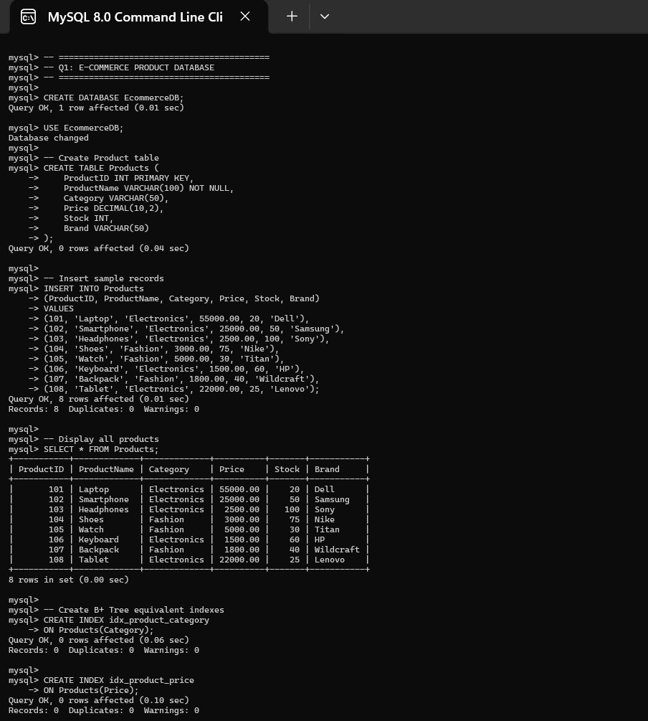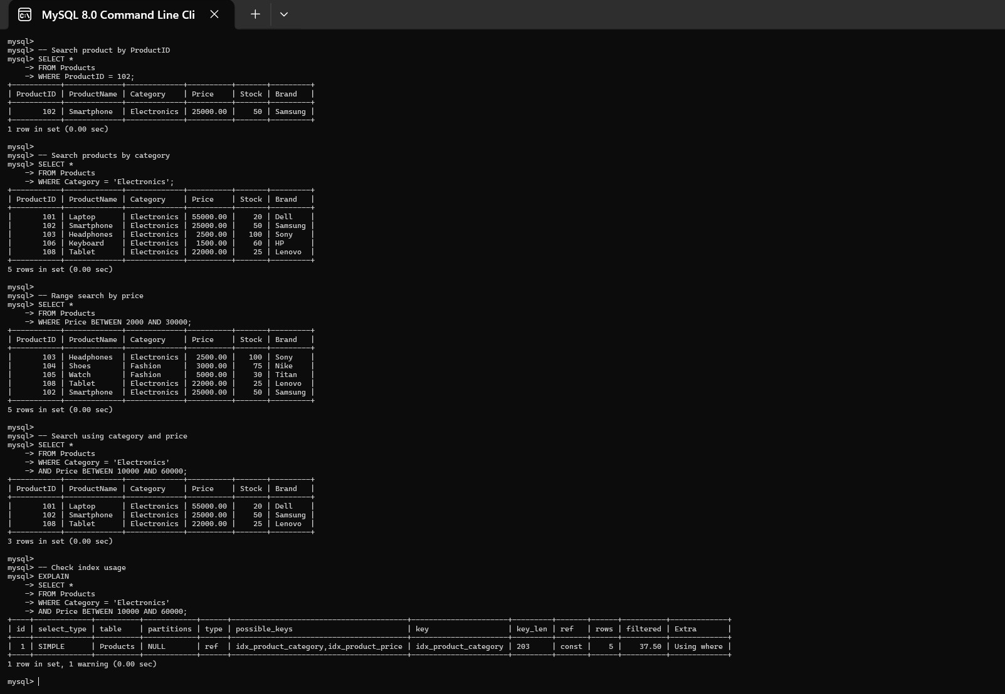
2. A banking system requires fast retrieval of transactions by account number and date range. Design an indexing strategy with appropriate index types.

Recommended Strategy: Composite B+ Tree Index
A banking system must quickly retrieve transactions using both Account Number and Transaction Date. The most appropriate solution is a composite B+ Tree index on (AccountNumber, TransactionDate).
1. Requirement
Consider a query:
SELECT *FROM Transactions
WHERE AccountNumber = 10525
AND TransactionDate BETWEEN '2026-01-01' AND '2026-03-31';
The system must first identify the account and then retrieve transactions within the specified date range. 2. Composite Index
Create:
B+ Tree Index (AccountNumber, TransactionDate)
The index is ordered first by AccountNumber and then by TransactionDate.
Example:
Account 1001 → Jan → Feb → Mar → Apr
Account 1002 → Jan → Feb → Mar → Apr Account 1003 → Jan → Feb → Mar → Apr
- Search Process
For a particular account:
  - Traverse the B+ Tree to locate the account.
  - Locate the first required date.
  - Follow the leaf-node links.
  - Retrieve transactions until the ending date is reached.
- Why B+ Tree?
B+ Trees are ideal for database systems because:
  - They have high fan-out.
  - Tree height remains small.
  - Searching requires approximately O(log N) index traversal.
  - Leaf nodes are linked.
  - They efficiently support range queries.
  - They work well with disk-based storage.
- Why Not Hashing?
A hash index is excellent for: AccountNumber = 10525
but poor for:
TransactionDate BETWEEN Date1 AND Date2
because hash buckets do not maintain sorted order.
6. Alternative Index
A separate index on: TransactionDate can also be maintained if the banking system frequently searches transactions across all accounts for a date range.
7. Performance Comparison
Feature | Hash Index | B+ Tree
Account exact search | Excellent | Excellent
Date range | Poor | Excellent
Account + date range | Moderate | Excellent
Ordered traversal | Poor | Excellent
Dynamic updates | Good | Good

Conclusion
A composite B+ Tree index on (AccountNumber, TransactionDate) is the best solution because it efficiently supports account-specific date-range queries and minimizes disk I/O.

SQL IMPLEMENTATION
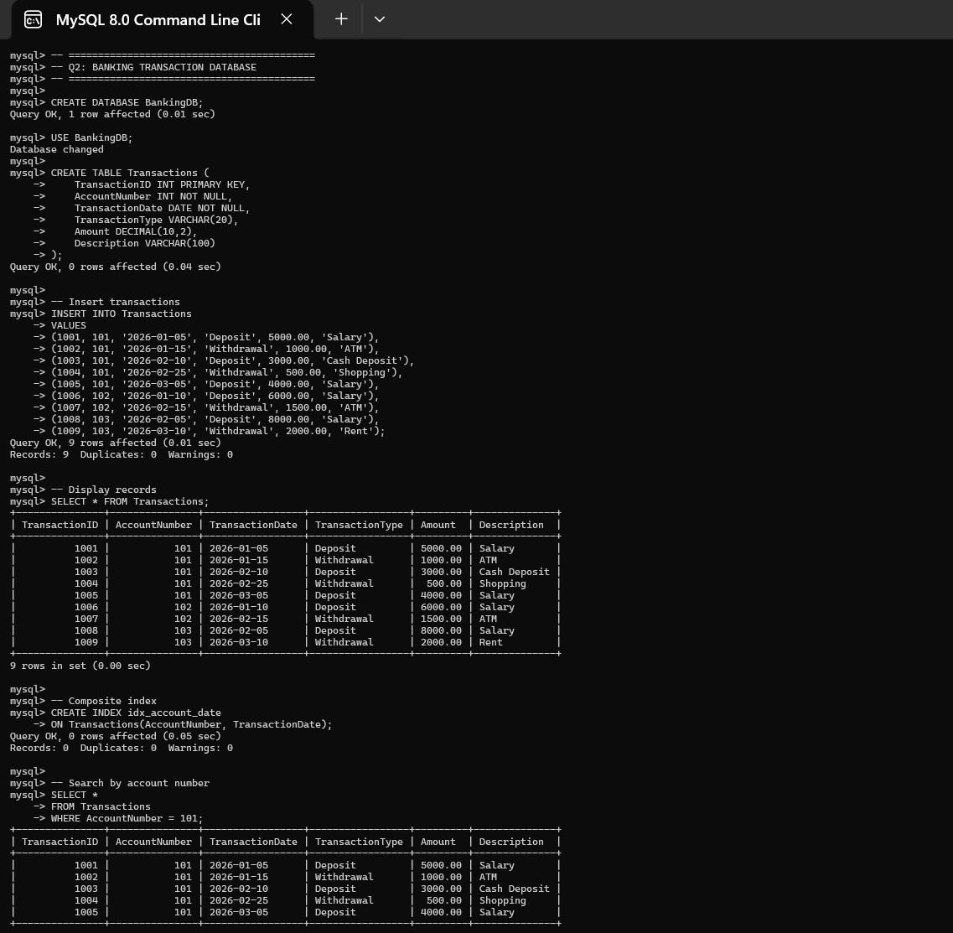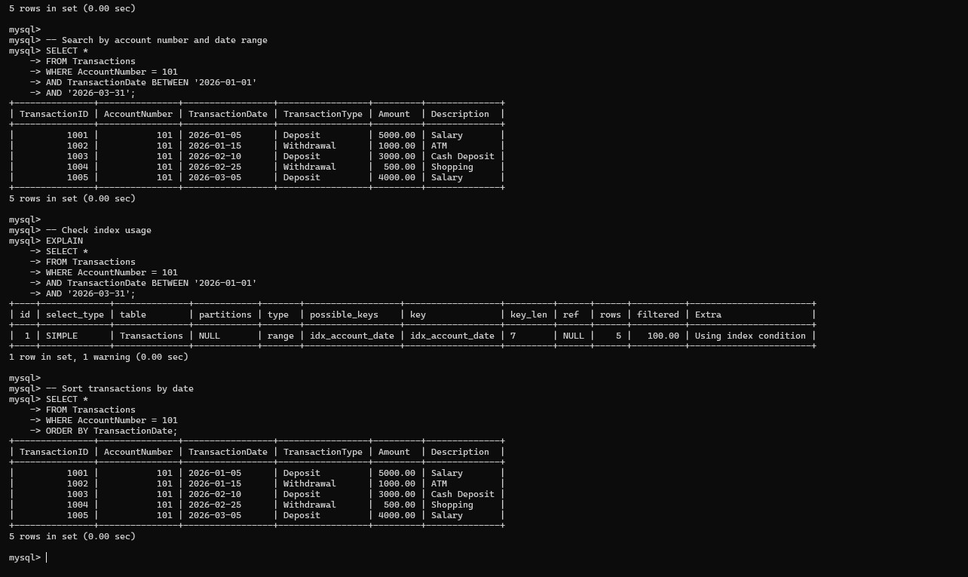

- A healthcare system stores patient records accessed both by PatientID and by doctor name. Design a multi-level indexing solution.
Healthcare – Multi-Level Indexing
Recommended Strategy: Two B+ Tree Indexes
Patient records need to be accessed using both PatientID and DoctorName. Therefore, separate indexes should be created.
Index 1 – PatientID
CREATE INDEX idx_patient_id
ON Patient(PatientID);
Since PatientID is usually unique, it provides very fast access to an individual patient.
Index 2 – DoctorName
CREATE INDEX idx_doctor_name
ON Patient(DoctorName);
This index allows the system to find all patients treated by a particular doctor.
Example
SELECT * FROM Patient
WHERE PatientID = 50125;
or
SELECT * FROM Patient
WHERE DoctorName = 'Dr. Rao';
Benefits
- Fast patient identification.
- Fast doctor-based retrieval.
- Supports large databases.
- Reduces full-table scanning.
- B+ Tree can grow dynamically.
Conclusion: Maintaining separate B+ Tree indexes on PatientID and DoctorName provides multiple efficient access paths.

Advantages
  - Fast PatientID retrieval.
  - Fast doctor-based retrieval.
  - Supports range queries if required.
  - Reduces disk accesses.
  - Suitable for millions of patient records.
  - Indexes can grow dynamically.
Disadvantages
Maintaining two indexes creates:
  - Additional storage requirements.
  - Extra insertion overhead.
  - Extra deletion/update overhead.
However, healthcare systems prioritize fast retrieval, so this overhead is justified.
Conclusion
A multi-level B+ Tree on PatientID and a separate secondary B+ Tree on DoctorName provides multiple efficient access paths and is suitable for a large healthcare database.
SQL IMPLEMENTATION
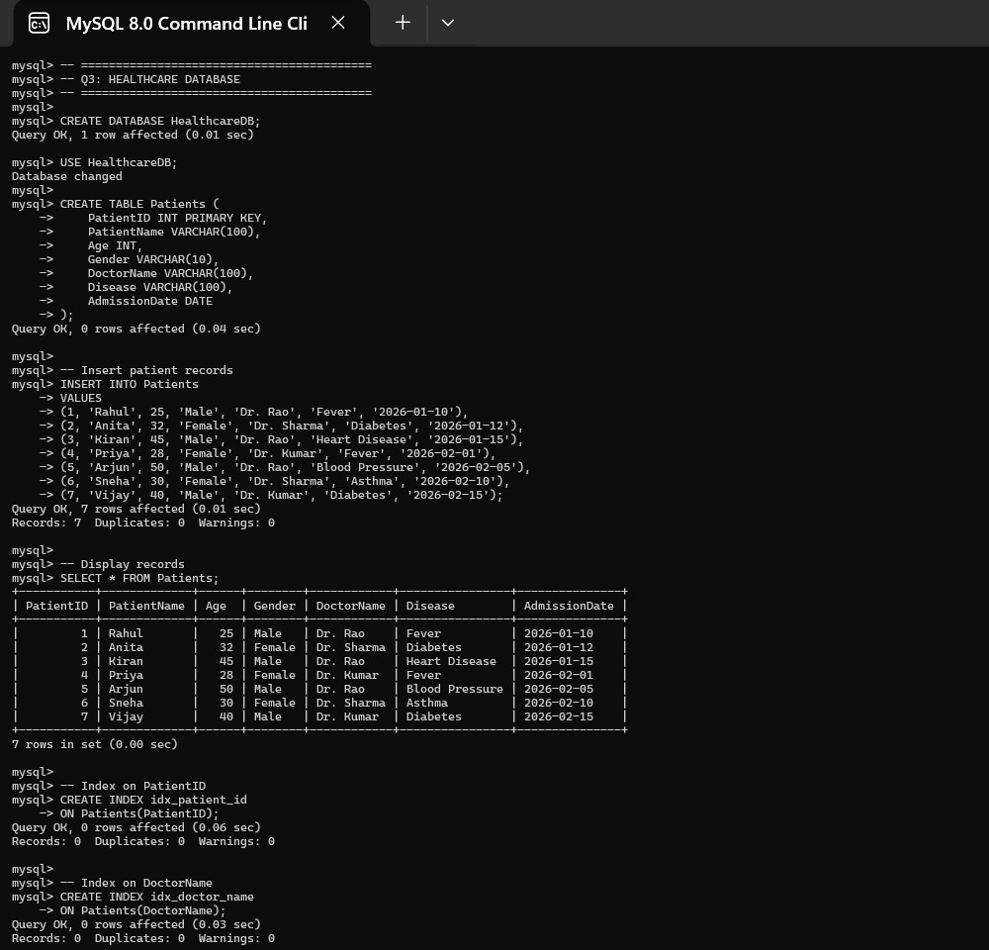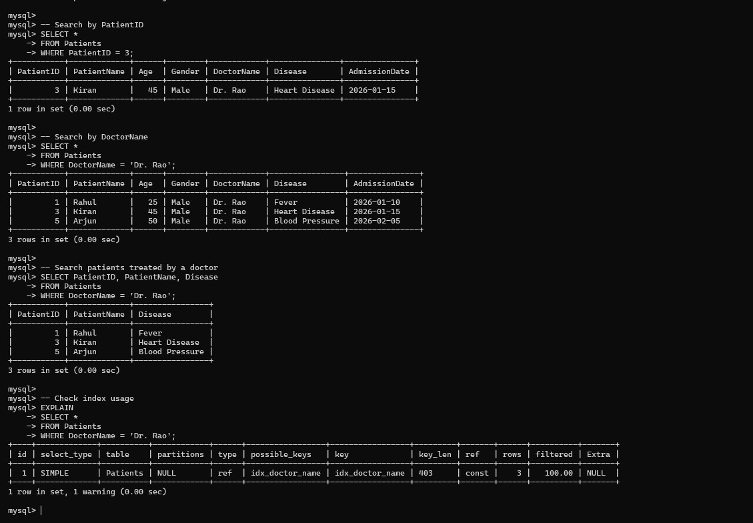
4. A logistics company needs to efficiently handle dynamic insertions and deletions of shipment records. Analyze whether B-Tree or B+ Tree is more suitable.

Recommended Choice: B+ Tree
A logistics company frequently inserts and deletes shipment records. It also needs to search shipments based on shipment ID, date, location, and delivery status. Between B-Tree and B+ Tree, B+ Tree is more suitable.
- B-Tree
In a B-Tree, both internal and leaf nodes can contain:
  - Search keys
  - Record pointers
Therefore, actual data may be found at different levels.
- B+ Tree
In a B+ Tree:
  - Internal nodes contain keys and child pointers.
  - Actual record pointers are stored at leaf nodes.
  - Leaf nodes are linked sequentially.
- Insertion
When a shipment is inserted:
  - Locate the appropriate leaf.
  - Insert the key.
  - If the leaf becomes full, split it.
  - Promote the separator key.
  - Continue upward if necessary.
- Deletion
When a shipment is deleted:
  - Locate the leaf.
  - Delete the key.
  - If the node becomes underfilled, redistribute entries or merge nodes.
  - Update the parent.

- Comparison
Feature | B-Tree | B+ Tree
Search | Good | Excellent
Insert | Good | Excellent
Delete | Good | Excellent
Range queries | Good | Excellent
Sequential access | Moderate | Excellent
Fan-out | Lower | Higher
Disk storage | Good | Excellent

- Why B+ Tree?
Logistics systems commonly require queries such as:
Find all shipments from 1 August to 15 August
B+ Tree can locate the first record and then traverse linked leaf nodes.
Higher fan-out also means fewer tree levels, resulting in fewer disk accesses.
Conclusion
B+ Tree is superior for the logistics system because it provides efficient dynamic insertion and deletion, high fan-out, excellent range queries, and fast sequential access.
SQL IMPLEMENTATION
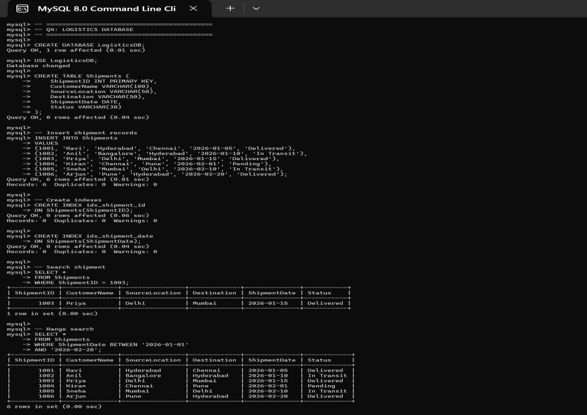
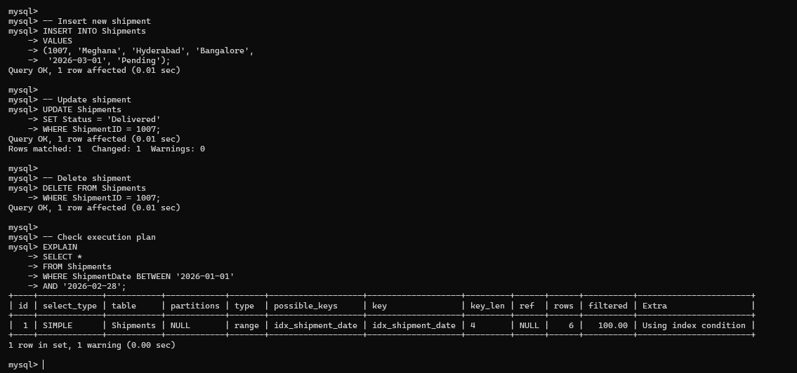

5.Design a hashing scheme for an HR system with 5000 employees. Evaluate static hashing vs. extendible hashing for your scenario.

Recommended Strategy: Extendible Hashing
An HR system containing 5,000 employees can use hashing for fast EmployeeID-based retrieval. Two possible methods are Static Hashing and Extendible Hashing.
Static Hashing
Suppose we create 500 buckets:
ℎ(𝐸𝑚𝑝𝑙𝑜𝑦𝑒𝑒𝐼𝐷) = 𝐸𝑚𝑝𝑙𝑜𝑦𝑒𝑒𝐼𝐷 mod 500
Each employee is assigned to a bucket based on the hash function.
Advantages
  - Simple.
  - Fast exact search.
  - Low implementation complexity.
  - Good when the number of records is fixed.
Disadvantages
If the company grows from 5,000 to 10,000 employees:
  - Existing buckets may become overloaded.
  - Overflow chains may develop.
  - Searching through overflow records reduces performance.
  - Reorganization can be expensive.
Extendible Hashing
Extendible hashing uses a directory and dynamically growing buckets.
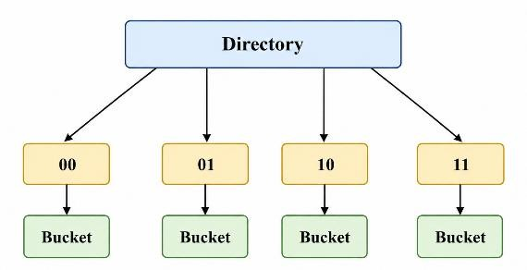
When a bucket becomes full, it can be split.
Advantages
  - Dynamic growth.
  - Less overflow.
  - Efficient exact searches.
  - Does not require rebuilding the entire file.
  - Suitable for changing employee populations.
Comparison
Feature | Static Hashing | Extendible Hashing
Implementation | Simple | More complex
Exact search | Excellent | Excellent
Growth | Poor | Excellent
Overflow | Higher | Lower
Dynamic resizing | Difficult | Easy
Scalability | Moderate | High

Conclusion
For exactly 5,000 relatively stable employees, static hashing is sufficient. However, extendible hashing is the better long-term solution because employee records may continuously increase or decrease.
SQL IMPLEMENTATION
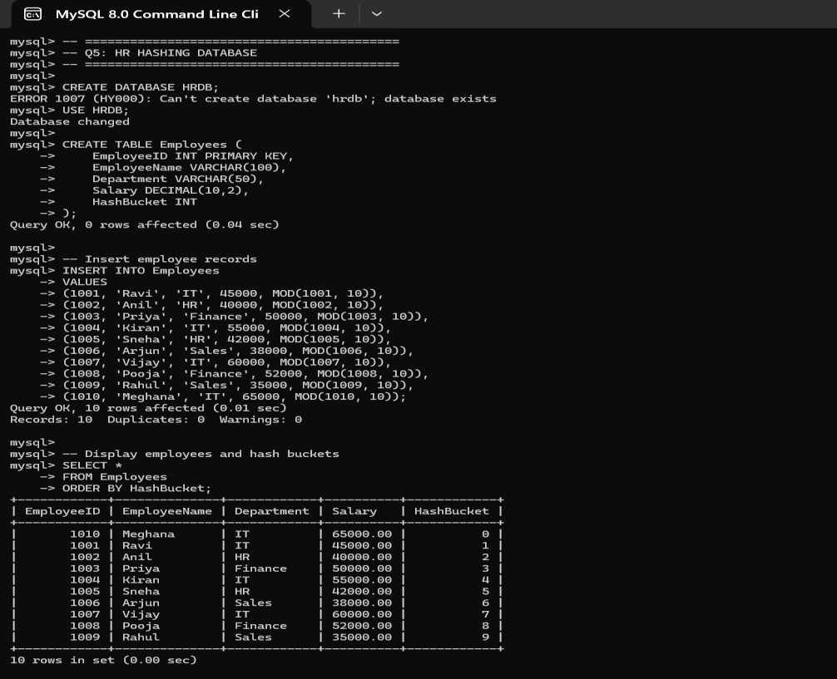
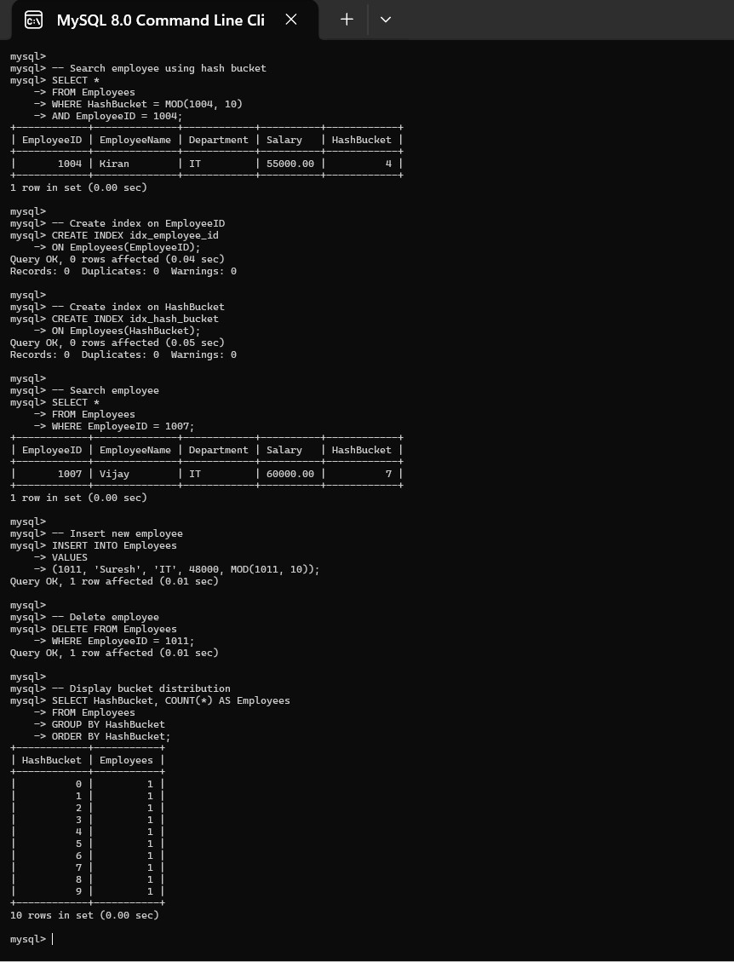

- An airline reservation system must support point queries by flight number and range queries by date. Propose a combined index structure.
An airline reservation system has two different requirements:
  - Point query using Flight Number.
  - Range query using Flight Date.
Since these operations have different characteristics, a combination of Hash Index + B+ Tree is recommended.
- Hash Index on Flight Number
Create:
Hash Index
FlightNumber → Reservation Records
Example:
SELECT * FROM Flight WHERE FlightNumber = 'AI202';
Hashing provides very fast average exact lookup.
- B+ Tree on Flight Date
Create:
B+ Tree
FlightDate → Reservation Records
It supports queries such as:
SELECT * FROM Flight
WHERE FlightDate BETWEEN '2026-08-01'
AND '2026-08-15';
- Combined Structure
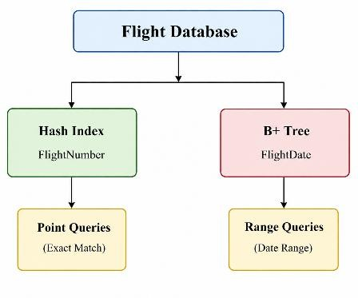
- Why Not Only Hashing?
Hashing is not suitable for date ranges because dates are not maintained in sorted order.

- Why Not Only B+ Tree?
A B+ Tree can support both operations, so technically a single B+ Tree could be used. However, a hash index can provide very efficient exact lookup when FlightNumber searches dominate.
6. Trade-Off
Using two indexes increases:
- Storage.
- Insert/update cost.
- Index maintenance.
But it provides specialized performance for both types of queries.
Conclusion
A Hash Index on FlightNumber and B+ Tree on FlightDate is an effective combined indexing solution for an airline reservation system. If minimizing index maintenance is more important, a single composite B+ Tree can be considered.
SQL IMPLEMENTATION
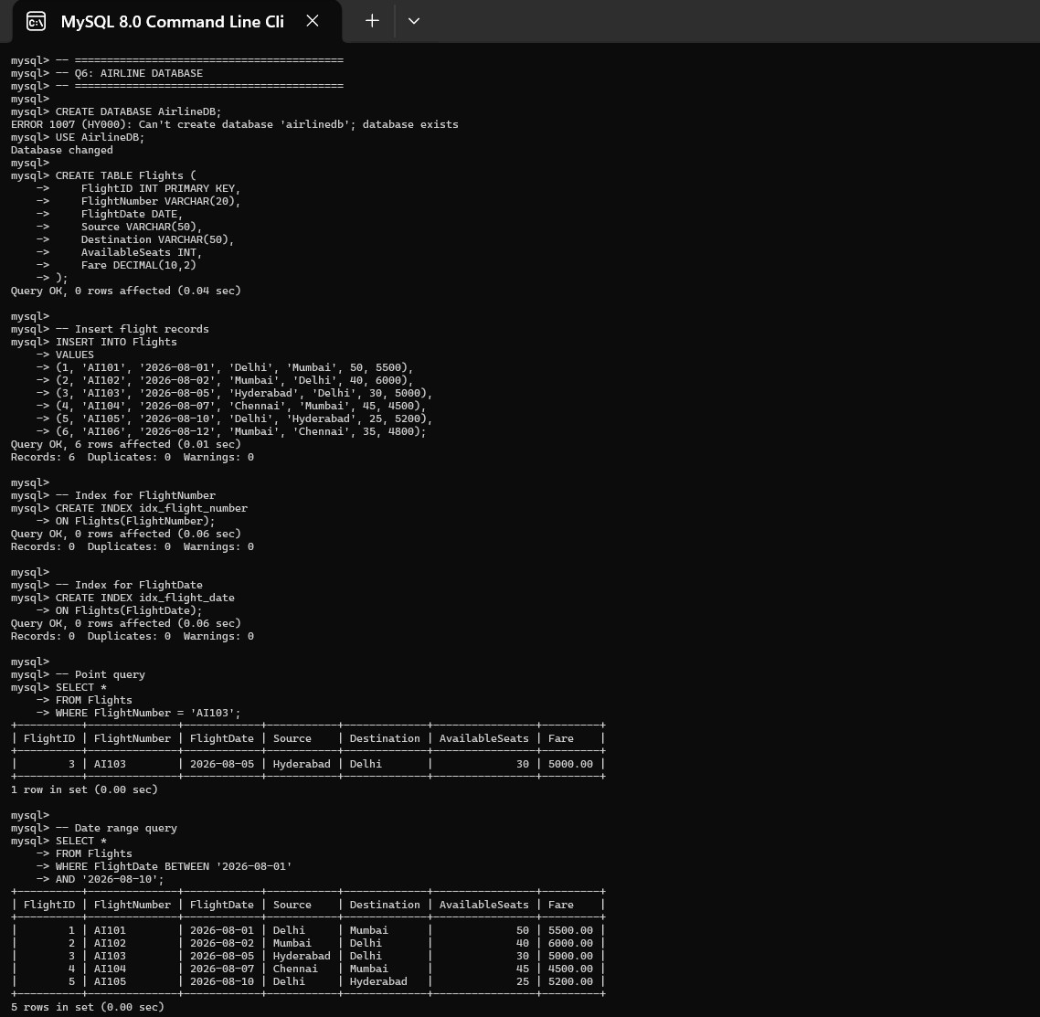
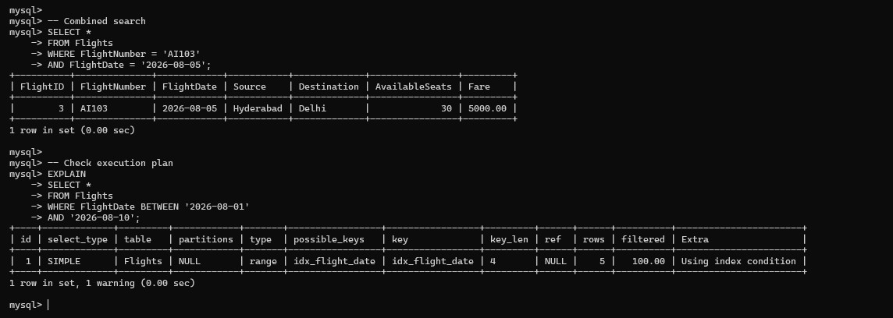

7. For a university student database, design the file organization and secondary indexing to support fast queries by department and CGPA range.

Recommended Strategy: Heap File + Secondary Composite B+ Tree
A university database contains student information such as:
StudentID
Name
Department
CGPA
Year
The system needs fast queries based on Department and CGPA range.
- File Organization
Use a Heap File to store student records.
Advantages:
  - Fast insertion.
  - No physical sorting required.
  - Easy record deletion.
  - Suitable for dynamic student records.
- Secondary Index
Create a composite B+ Tree:
B+ Tree (Department, CGPA)
The first key is Department, followed by CGPA.
- Example Query
SELECT * FROM Student WHERE Department = 'CSE' AND CGPA BETWEEN 8.0 AND
9.5;
The composite B+ Tree index is created on (Department, CGPA). When this query is executed, the index first searches for the CSE department. After locating the CSE entries, it performs a range scan on the CGPA values and retrieves students whose CGPA is between 8.0 and 9.5. This avoids scanning the complete student table and improves query performance.
Example:
  - Department = CSE
  - CGPA ≥ 8.0
  - CGPA ≤ 9.5
  - Only matching student records are retrieved.
- Index Structure
B+ Tree
|
Department + CGPA
/ | \
CSE ECE EEE
|
CGPA 8.0–9.5
|
Student Records
- Why B+ Tree?
It supports:
  - Equality search.
  - Range search.
  - Ordered traversal.
  - Efficient disk access.
  - Dynamic insertion and deletion.
- Additional Index
If StudentID searches are extremely frequent, another B+ Tree or primary index can be maintained on StudentID.
- Trade-Off
Additional indexes increase storage and update costs, but improve query response time.
Conclusion
The best design is a Heap File for student records with a secondary composite B+ Tree on (Department, CGPA). This provides efficient department filtering and CGPA range retrieval while maintaining flexible storage.
SQL IMPLEMENTATION
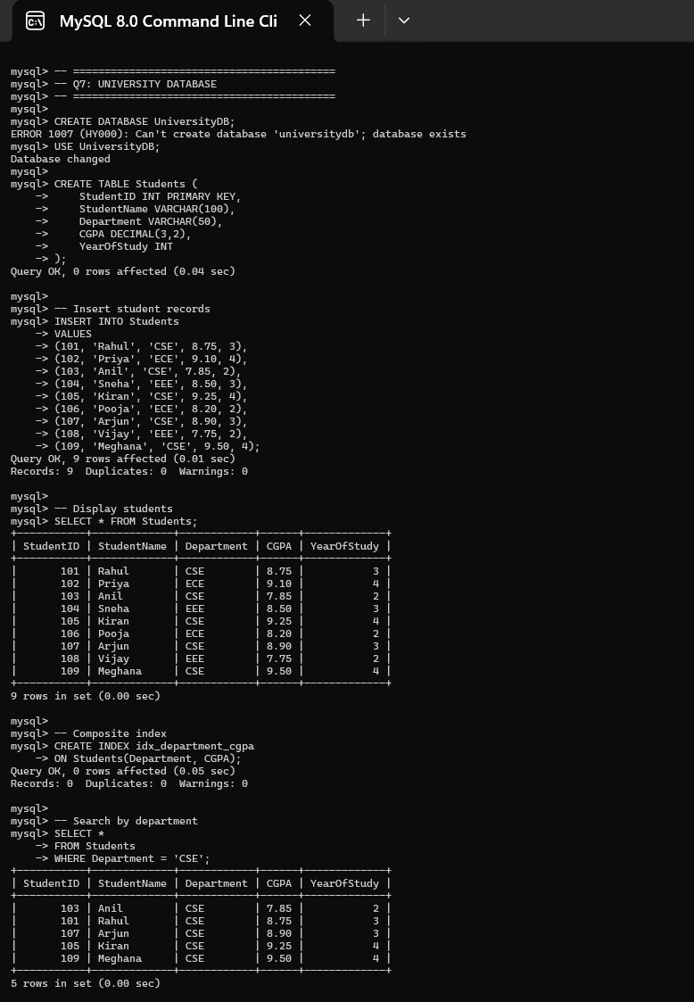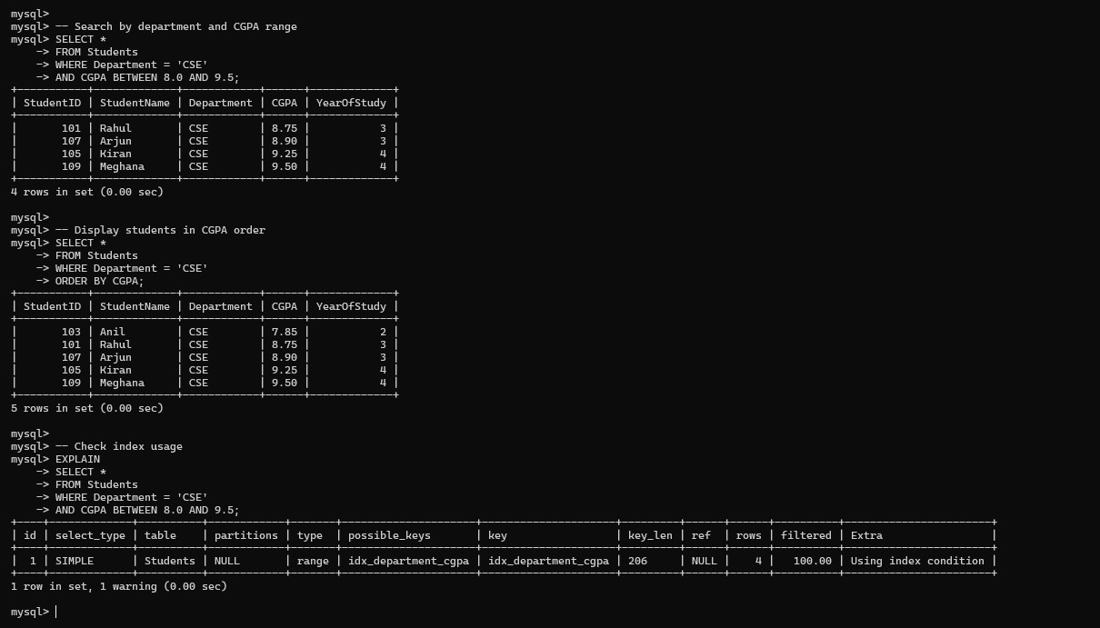
- Analyze the disk block utilization for Heap, Sorted, and Hashed file organizations given 100,000 records with 50 bytes each and 4KB blocks.

Given Data
  - Number of records = 100,000
  - Record size = 50 bytes
  - Block size = 4 KB
  - 4 KB = 4096 bytes
Step 1: Records per Block
Records per block = ⌊⌋
= 81

Therefore, each block can contain 81 records.
Step 2: Number of Blocks
Blocks = ⌈⌉
= 1235 𝑏𝑙𝑜𝑐𝑘𝑠

Step 3: Total Record Storage
100000 × 50 = 5,000,000 𝑏𝑦𝑡𝑒𝑠

This is approximately:
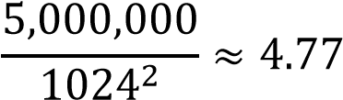 𝑀𝐵

Step 4: Allocated Storage
1235 × 4096 = 5,058,560 𝑏𝑦𝑡𝑒𝑠

Step 5: Unused Space
5,058,560 − 5,000,000 = 58,560 𝑏𝑦𝑡𝑒𝑠

Step 6: Utilization
Utilization =  × 100
= 98.84%

Thus, approximately 98.84% of the allocated block space is used.
Comparison
File  Organization | Approx.Data  Blocks | Utilization | Important Characteristic
Heap | 1235 | 98.84% | Unordered
Sorted | 1235 | 98.84% | Ordered
Hashed | ≈1235 ideally | ≈98.84% ideally | Hash-based placement

Heap File:
Records are placed wherever space is available.
Advantage: Fast insertion.
Disadvantage: Searching may require a full scan.
Sorted File:
Records are maintained in sorted order.
Advantage: Excellent sequential and range access.
Disadvantage: Insertions can be expensive because records may need to be moved.
Hashed File:
Records are placed using a hash function.
Advantage: Very fast equality searches.
Disadvantage: Collisions can create overflow blocks and reduce actual utilization.
Conclusion
All three can theoretically achieve approximately 98.84% utilization when records are packed efficiently. However, actual hashed utilization may be lower due to collisions, while sorted files may require extra free space to accommodate future insertions.

SQL IMPLEMENTATION
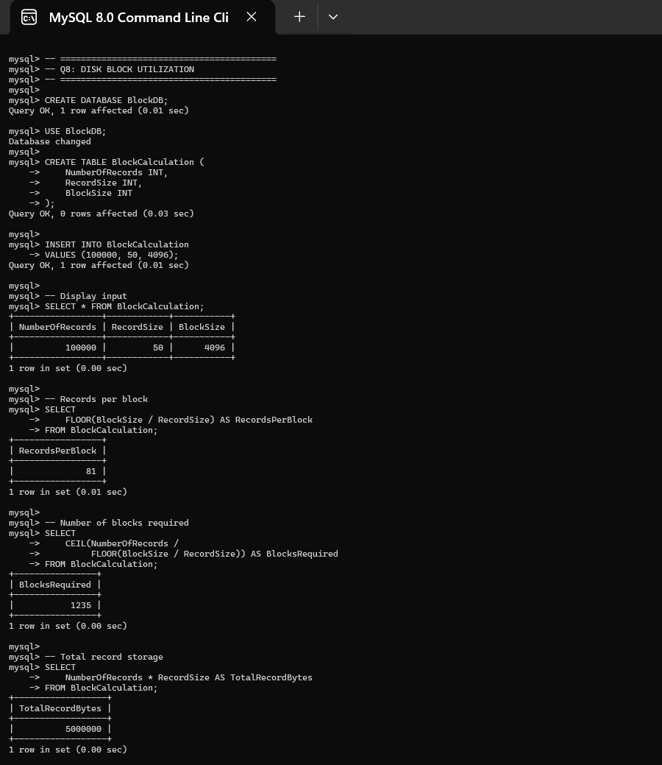
9. A social media platform needs to index 500 million posts by user_id, timestamp, and hashtag. Design a composite indexing strategy.

Recommended Strategy: Composite B+ Tree Indexing with Partitioning
A social media platform with 500 million posts represents a very large database. It needs efficient access using:
- user_id
- timestamp
- hashtag
A single index on all three attributes may not be suitable for every query. Therefore, a combination of composite indexes and partitioning is recommended.
- User-Based Composite Index
Create: B+ Tree (user_id, timestamp) This supports: Find all posts by a user and:
Find a user's posts during a specific period
Example:
WHERE user_id = 10025
AND timestamp BETWEEN T1 AND T2;
- Hashtag-Based Composite Index
Create: B+ Tree (hashtag, timestamp) This supports: Find all #AI posts and:
Find #AI posts created during the last 24 hours
- Timestamp Partitioning
With 500 million records, partitioning is highly beneficial.
For example:
Posts
|
+-- January 2026
+-- February 2026
+-- March 2026
+-- April 2026
+-- ...
When a query requests recent posts, the DBMS can avoid scanning old partitions.
- Proposed Architecture
500 Million Posts
|
Time-Based Partitions
|
----------------------- | |
(user_id,timestamp) (hashtag,timestamp)
| |
User Timeline Hashtag Search
- Advantages
  - Fast user timeline retrieval.
  - Efficient hashtag searches.
  - Efficient time-range queries.
  - Partition pruning reduces unnecessary disk I/O.
  - B+ Tree supports ordered timestamp access. • Scales better for continuously growing data.
- Important Trade-Off Creating too many indexes causes:
  - Higher storage usage.
  - Higher insertion cost.
  - Higher update/delete cost.
  - More index maintenance.
Therefore, indexes should be created only for frequently executed queries.
Conclusion
For 500 million social media posts, use time-based partitioning with composite B+ Tree indexes (user_id, timestamp) and (hashtag, timestamp). This design provides scalability and efficient retrieval while controlling the cost of indexing a very large dataset.

SQL IMPLEMENTATION
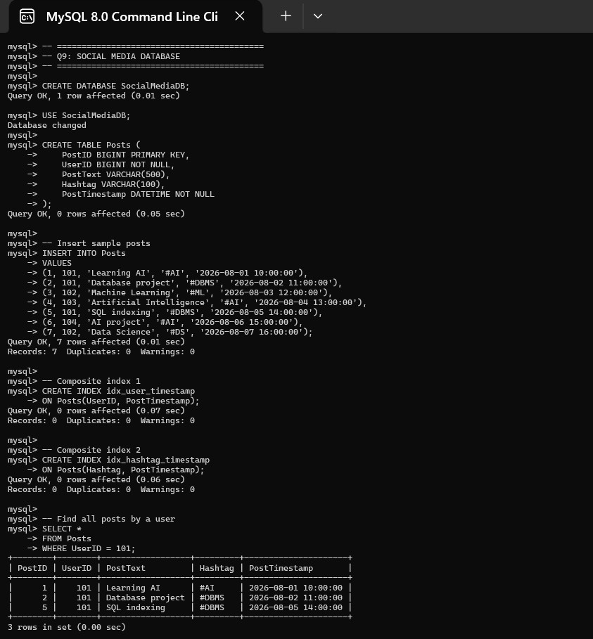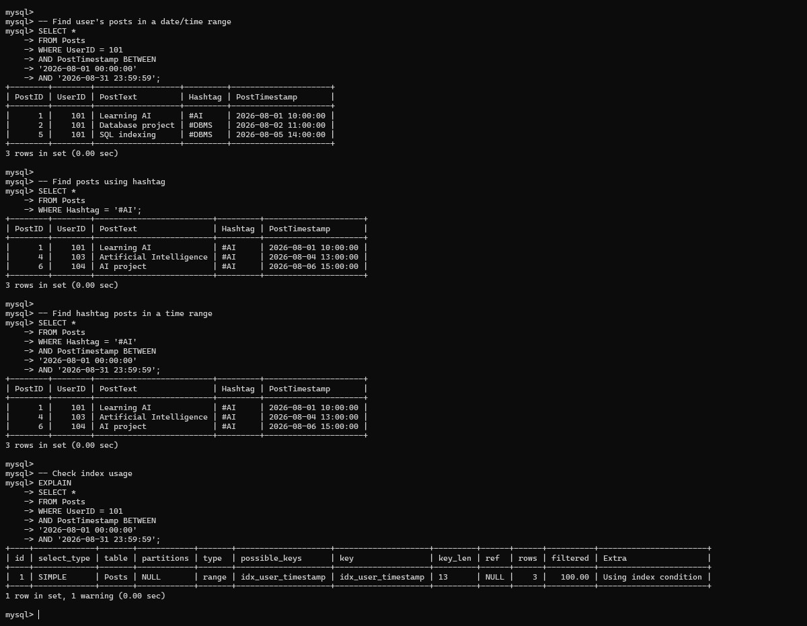
10. Compare the performance (insert, delete, search time) of Heap File, Sorted File, and Hashed File for a supermarket billing system with 1 million daily transactions.

A supermarket billing system handles approximately 1 million transactions per day. The system needs fast transaction insertion and retrieval.
The three possible file organizations are:
- Heap File
- Sorted File
- Hashed File
1. Heap File
Records are stored without any particular order.
Insert
A new transaction can be added to a free location.
Average cost: approximately O(1)
Search
Without an index, the system may need to scan the file.
Cost: O(N)
For 1 million records, this can be expensive.
Delete
Finding the record may require a scan.
Cost: O(N) without an index.
Advantage
Excellent for high-volume transaction insertion.
2. Sorted File
Transactions are stored according to a key such as:
TransactionID or TransactionDate
Search
Binary search can be used.
Cost: approximately O(log N) for locating records.
Range Search
Very efficient.

For example:
Find all transactions between 10:00 AM and 12:00 PM can be performed efficiently because records are ordered.
Insert
Insertion can be expensive because records may need to be shifted.
Cost: approximately O(N) in the worst case.
Advantage
Excellent for reporting and range queries.
3. Hashed File
A hash function maps each transaction to a bucket.
For example:
ℎ(𝑇𝑟𝑎𝑛𝑠𝑎𝑐𝑡𝑖𝑜𝑛𝐼𝐷) = 𝑇𝑟𝑎𝑛𝑠𝑎𝑐𝑡𝑖𝑜𝑛𝐼𝐷 𝑀𝑂𝐷 𝑀
Insert
Average: 𝑂(1)

Exact Search
Average:𝑂(1)

Therefore, searching for:
TransactionID = 100245 is extremely fast.
Range Search
Poor because hash values do not preserve the order of TransactionID or Date
- Comparison
Operation | Heap | Sorted | Hashed
Insert | O(1) average | O(N) | O(1) average
Exact Search | O(N) | O(log N) | O(1) average
Delete | O(N) | O(N) | O(1) average
Range Search | O(N) | O(log N + k) | Poor
Sequential Access | Good | Excellent | Poor
Overflow | No | No | Possible
Here, k represents the number of records returned by a range query.

- Best Choice
If the supermarket mainly performs:
Find transaction using TransactionID , then Hashed File Organization is the best choice.
If the system mainly performs:
Daily sales reports
Hourly transaction reports
Transactions between two dates, then a Sorted File or B+ Tree index is more suitable.
Practical Recommendation
For a real supermarket system handling 1 million transactions daily:
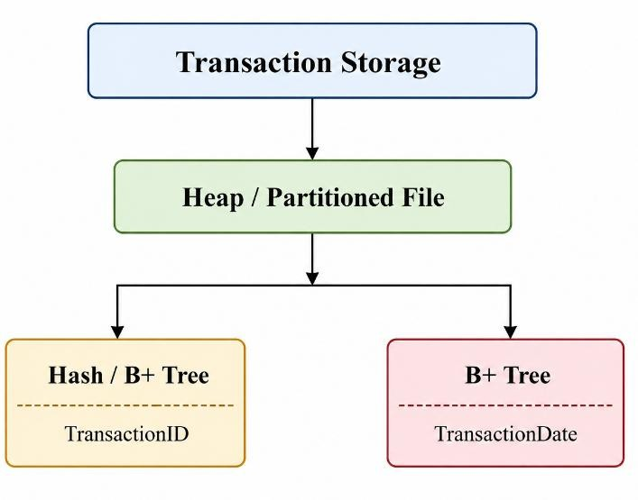
This hybrid approach gives:
  - Fast transaction insertion.
  - Fast exact transaction lookup.
  - Efficient date-range reports.
  - Better scalability.
Conclusion
For pure exact transaction lookup, Hashed File is the best because of its O(1) average search and insertion. However, for a practical supermarket billing system with both billing and reporting requirements, a Heap/partitioned file with Hash or B+ Tree indexes provides the best overall performance and scalability.

SQL IMPLEMENTATION
